S.NO | NAME | DESIGNATION | QUALIFICATION, AWARDING AUTHORITY  WITH YEAR OF AWARD | DATE OF BIRTH | REG. NO. AND DATE OF REGISTRATION WITH NAME OF COUNCIL /BOARD | EXPERIENCE IN TEACHING CADRE AND DURATION AND NAME INSTITUTION WHERE SUCH EXPERIENCE GAINED | PHOTO
1. | DR. UPENDRA KUMAR VERMA | PRINCIPAL | DHMS 1986 BRA B.U M.D. (HOM.) 2004 MARATHWADA UNIV. MAHARASHTRA | 05/07/1963 | 23576 DT 16/01/1990 BIHAR STATE BOARD OF HOM. MED. | DEMONS. 06/3/1991 TO 21/8/1995, LECT. FROM 22/8/95 TO 2/8/1999 READER 03/8/99 TO 05/09/2001 IN BHMCH, PATNA AND AT GDMHMCH READER FROM 6/9/2001 TO 13/10/2003 , PROF. SINCE 14/10/2003 and  Principal Since 06/02/2025 AT GDMHMCH | 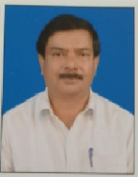

S.NO | NAME | DESIGNATION | DEPARTMENT | FT/GF | QUALIFICATION, AWARDING AUTHORITY  WITH YEAR OF AWARD | DATE OF BIRTH | REG. NO. AND DATE OF REGISTRATION WITH NAME OF COUNCIL /BOARD | EXPERIENCE IN TEACHING CADRE AND DURATION AND NAME INSTITUTION WHERE SUCH EXPERIENCE GAINED | PHOTO
1 | DR. HARIJEE SINGH | PROFESSOR | ANATOMY | FT | BHMS 1989  BRA BIHAR UNIVERSITY | 12/01/1960 | 24340 DT 5/9/91  BIHAR STATE BOARD OF HOM. MED. | DEMONS.- 8/11/91TO 15/9/96, LECT. 16/9/96 TO 20/5/02, READER 21/5/2002 TO 11/3/08 PROFESSOR -12/3/08 TO 18/5/2012 B.H. M.C. & H, BIHAR AND AT GDMHMCH SINCE 19/05/2012 | 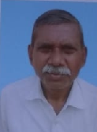
2 | DR. JAY PRAKASH SHARMA | PROFESSOR | ANATOMY | FT | BHMS 1983  BRA BIHAR UNIVERSITY | 13/1/1968 | 25752 DT 1/4/1988  BIHAR STATE B. H.MED. | DEMONS. AT G.D.M.H.M..CH. SINCE 27/3/2001 TO 11/8/2004 LECT. 12/8/04 TO  14/09/09 READER FROM 15/09/2009 TO 31/5/2022 AND PROFESSOR SINCE 01/06/2022 | 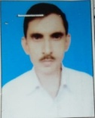
3 | DR. MANOJ KUMAR SINGH | ASSOCIATE PROFESSOR | ANATOMY | FT | BHMS 2006  J RN RAJASTHAN VIDYAPEETH UNIVERSITY | 3/5/1983 | 28290 DT 15/5/2007 BIHAR STATE BOARD OF HOM. MED. | AT GDMHMC& H, PATNA  LECTURER FROM 1/3/2013 TO 31/5/2022 AND ASSOCIATE PROFESSOR SINCE 01/06/2022 | 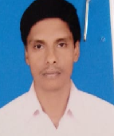
4 | DR. NARAYANI KUMARI | ASSISTANT PROFESSOR | ANATOMY | FT | BHMS BRA BU IN 2016 AND M.D. (HOM.) APRIL 2022 | 10/01/1993 | 32783 DT 09/8/2018 BIHAR STATE BOARD OF HOM. MED | ASSISTANT PROFESSOR AT G. D. M H. M.CO.& H SINCE 01/05/2022 | 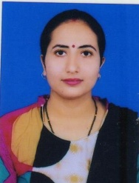
5 | DR. ABHISHEK RISHI | ASSISTANT PROFESSOR | ANATOMY | FT | BHMS BRA BU IN 2015 AND M.D. (HOM.) APRIL 2021 | 27/02/1992 | 32374 BIHAR STATE BOARD OF HOM. MED. | ASSISTANT PROFESSOR SINCE 07/10/2022 IN GDMHMCH | 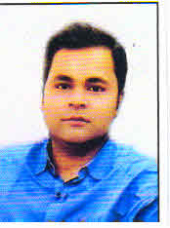
6 | DR. SUDHAKAR | PROFESSOR | PHYSIOLOGY | FT | DHMS 1991 BRA BIHAR UNIVERSITY  M.D. (HOM.) 2011 BRA BIHAR UNIV. | 28/8/1958 | 25182 DT 8/8/1995 BIHAR STATE BOARD OF HOM. MED. | DEMONS. 6/3/96 TO 12/4/2000 LECT. 13/4/2000 TO 20/7/2005 , READER 21/7/2005 TO 16/12/2010 PROFESSOR-FROM 17/12/2010 TO 30/11/2011 BHMCH, PATNA AND AT GDMHMCH,PATNA PR. SINCE 1/12/2011 | 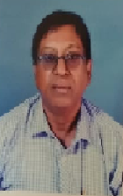
7 | DR. ASHOK KUMAR YADAV | PROFESSOR | PHYSIOLOGY | FT | DHMS 1992 BRA BIHAR UNIVERSITY | 11/03/1965 | 25465 DT 28/11/95 BIHAR STATE BOARD OF HOM. MED. | DEMONS.- 05/12/95 TO 24/01/2002  B.H. M.C. & H, BIHAR  AND AT GDMHMCH LECTURER APPOINTMENT ON 2/2/2002 TO 04/02/2007 READER 05/02/2007 TO 13/3/2011 AND  PROFESSOR SINCE14/3/11 | 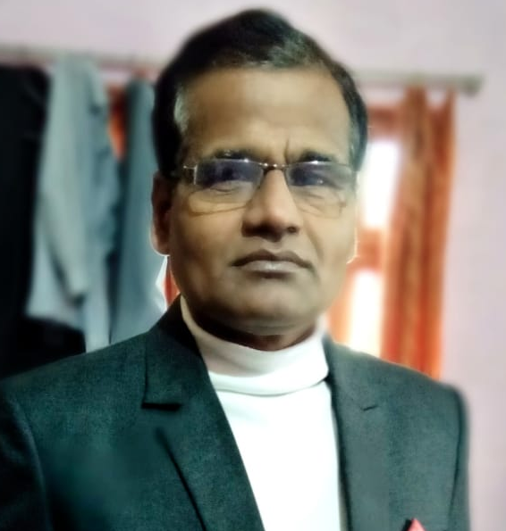
8 | DR. SUNIL KUMAR SINGH | ASSOCIATE PROFESSOR | PHYSIOLOGY | FT | DHMS -2000 COUNCIL OF HOMOEOPATHY W.B.,-BHMS GRADED, 2005, JRN RAJASTHAN VIDY. UNIV. | 23/10/1976 | 28109 DT 2/5/2007  BIHAR BOARD OF HOM. MEDICINE | LECTURER SINCE 1/10/2011TO 3/1/2023, ASSOCIATE PROFESSOR SINCE 04/01/2023  G. D. M. H.M.C.H PATNA | 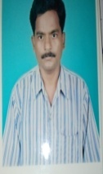
9 | DR. ASHUTOSH KUMAR | ASSISTANT PROFESSOR | PHYSIOLOGY | FT | BHMS 2016, BRA BIHAR UNIVERSITY,  M.D. (HOM.) 2021 BRA BIHAR UNIV | 02/02/1987 | 32716 DT 23/7/2018  BIHAR STATE BOARD OF HOM. MED. | ASSISTANT PROFESSOR SINCE 07/10/2022 IN GDMHMCH | 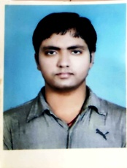
10 | DR. ANTRIKSH KUMAR SINHA | ASSISTANT PROFESSOR | PHYSIOLOGY | FT | BHMS 2018, BRA BIHAR UNIVERSITY,  M.D. (HOM.) 2023 BRA BIHAR UNIV | 05/10/1993 | 33334 DT 12/7/10/19  BIHAR STATE BOARD OF HOM. MED. | ASSISTANT PROFESSOR SINCE 08/08/2024 IN GDMHMCH | 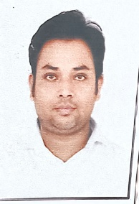
11 | DR. UDAY NARAYAN SINHA | PROFESSOR | PATHOLOGY | FT | DHMS, BIHAR UNIVERSITY 1999  BHMS GREADED 2009 BRA BIHAR UNIVERSITY | 30/5/1967 | 26109 DT. 09/09/1999  BIHAR STATE BOARD OF HOM. MED. | Demons. 7/2/2000 to 12/4/2005, lect. 13/4/2005 to 18/8/2010, Reader 19/8/2010 to 12/3/2012, In GDMHMC&H as 13Reader FROM 13/3/2012 TO 31/08/2023 AND PROFESSOR SINCE 01/09/2023 | 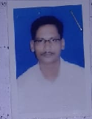
12 | DR. ASHWINI KUMAR MISHRA | PROFESSOR | PATHOLOGY | FT | BHMS – 2008 FROM DR BHIMRAO AMBEDKAR UNIV. , AGRA  M.D (HOM.) 2014 BRA BIHAR UNIVERSITY | 01/01/1978 | H029171 DT. 24/09/2009  HOM. MEDICINE BOARD , UP | ASSISTANT PROF – 02/02/2015 TO 05/05/2019, ASSOCIATE PROF. FROM 06/5/2019 TO 05/05/2022 AND PROFESSOR 06/5/2022 TO 30/6/2024 AT MAHARSHI MENHI HO. MED. COLLEGE AND HOSPITAL, KATIHAR,  PROFESSOR AT G D MEMORIAL HOM. MEDICAL COLLEGE & HOSPITAL SINCE 14/08/2024 | 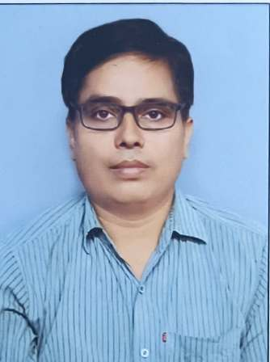
13 | DR. AZIM ANSARI | ASSOCIATE PROFESSOR | PATHOLOGY | FT | B.H.M.S. 1987 BRA BIHAR UNIVERSITY | 17/11/1959 | 23522 DT. 16/12/1989 BIHAR STATE BOARD OF HOM. MED | APPOINTED PROVISIONALLY AS DEMONSTRATOR FROM 18/12/1993 TO 07/08/2002 IN THE DEPT. OF PATHOLOGY AND LECTURER FROM  08/08/2002 TO 14/02/2012 B.H. M.C. & H BIHAR  AND ASSISTANT PROF AT GDMHMCH FROM 12/2/2012 TO 31/03/2025 AND ASSOCIATE PROFESSOR SINCE 01/04/2025 | 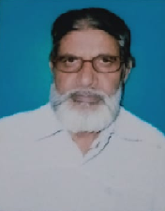
14 | DR. MOHAN LAL PANDIT | PROFESSOR | FORENSIC MEDICINE AND TOXICOLOGY | FT | BHMS 1993  BRA BIHAR UNIVRSITY | 02/02/1962 | 25739 DT. 07/03/1998 BIHAR STATE BOARD OF HOM. MED. | DEMONS. IN THE DEPT. FMT. FROM 01/04/1998 TO 14/04/2002, LECTURER 15/4/2002 TO 20/11/2006, READER FROM 21/11/2006 TO 28/3/2012 AT BHMCH AND  PROFESSOR SINCE 01/4/2012 AT GDMHMCH | 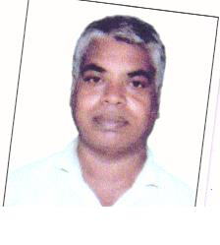
15 | DR. ANIL KUMAR GUPTA | PROFESSOR | FORENSIC MEDICINE AND TOXICOLOGY | FT | B.H.M.S 1993 BRA BIHAR UNIVERSITY | 01/07/1965 | 25791 DT 16/5/1993 BIHAR STATE BOARD OF HOM. MED. | DEMONS. FROM 02/02/2001 TO 11/8/2004, LECT. 12/8/04 TO 14/09/09 READER FROM 15/09/09 TO 31/08/23 AND PROFESSOR SINCE 01/09/23 AT  GDMHMCH, PATNA | 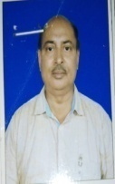
16 | DR. FARIDI AMIN | ASSOCIATE PROFESSOR | FORENSIC MEDICINE AND TOXICOLOGY | FT | BHMS 2009 BRA BIHAR UNIVERSITY  MD (HOM.) 2015 BRA BIHAR UNIVERSITY | 10/03/1983 | 29575 DT 28/04/2011 BOARD OF HOM. MED., BIHAR | \LECTURER FROM 23/12/2015 TO 08/10/2021  ASSOCIATE PROFESSOR IN GDMHMCH SINCE 09/10/2021 | 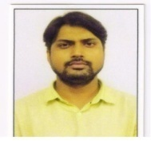
17 | DR. SUMAN LATA | ASSISTANT PROFESSOR | FORENSIC MEDICINE AND TOXICOLOGY | FT | BHMS 2017 GURU GOBIND SINGH INDRAPRASTHA UNIVERSITY,DELHI  MD(HOM.) 2023 WEST BENGAL UNIVERSITY OF HEALTH SCIENCES | 27/06/1994 | 34278 DT 30/06/2021 BOARD OF HOM. MED., BIHAR | ASSISTANT PROFESSOR AT GDMHMCH SINCE 01/09/2025 | 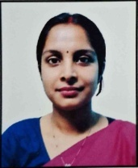
18 | DR. ASHWANI KR. SINGH | PROFESSOR | PRACTICE OF MEDICINE | FT | DHMS 1989  BRA BIHAR UNIVERSITY | 29/11/1966 | 23742 DT 10/5/1990 BIHAR STATE BOARD OF HOM. MED. | DEMONS.- 4/7/91TO 12/8/94 LECT. 13/8/94TO 18/9/98 READER 19/9/98TO 26/9/2002 PR. -27/9/2002TO 10/10/2003 B.H. M.C. & H, BIHAR AND AT GDMHMCH –22PROFESSOR SINCE 11/10/2003 | 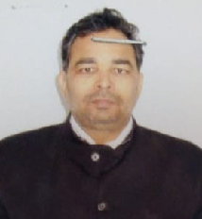
19 | DR. SUBODH KR. SINHA | PROFESSOR | PRACTICE OF MEDICINE | FT | DHMS 1987 BRA B.U. | 12/8/1961 | 23189 DT 26/12/86 BIHAR STATE BOARD OF HOM. MED. | DEMONS.- 4/5/94TO 8/9/98LECT. 9/9/98TO 10/3/04 READER 11/3/04 TO 31/8/06 B.H. M.C. & H, BIHAR  AND READER AT GDMHMCH FROM 01/09/2006 TO 31/08/2023 AND PROFESSOR SINCE 01/09/2023 | 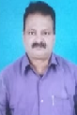
20 | DR. AKASH SINGH | ASSOCIATE PROFESSOR | PRACTICE OF MEDICINE | FT | BHMS 2012 BRA BIHAR UNIVERSITY  M.D. (HOM.) 2018, BRA BIHAR UNIVERSITY | 30/07/1990 | 30769 DT 10/04/2014 BIHAR STATE BOARD OF HOM. MED., BIHAR | ASSISTANT PROFESSOR FROM 01/02/2019 TO 31/8/2023 AND ASSOCIATE PROFESSOR SINCE 01/09/2023 AT GDMHMCH | 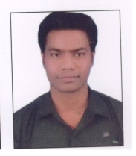
21 | DR. VENKATESH TIWARY | ASSOOCIATE PROFESSOR | PRACTICE OF MEDICINE | FT | BHMS 2005 BRA B.U | 25/6/1972 | 27846 DT 10/11/2006 BIHAR STATE BOARD OF HOM. MED. | APPOINTED PROVISIONALLY AS LECTURER IN THE DEPT. OF PRACTICE OF MEDICINE FROM 26/12/2010 TO 28/02/2013AND FINALLY LECTURER  FROM 1/3/2013 TO 29/2/2024 AND ASSOCIATE PROFESSOR FROM 01/03/2024 AT GDMHMCH | 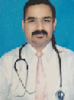
22 | DR. PRASHANT KUMAR DUBEY | ASSISTANT PROFESSOR | PRACTICE OF MEDICINES | FT | BHMS 2015 – BRA BU, MD (HOM) 2021 – BRA BU | 13/03/1991 | 32414 BOARD OF HOM. MED., BIHAR | ASSISTANT PROFESSOR AT GDMHMCH SINCE 01/01/2024 | 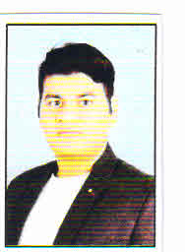
23 | DR. BRAHMADEO PRASAD SINGH | ASSOCIATE PROFESSOR ON CONTRACT BASIS | SURGERY | FT | BHMS 1986 BRA BIHAR UNIVERSITY | 07/05/1957 | 22845 DT 21.03.1988 BIHAR BOARD OF HOM. MED. | APPOINTED PROVISIONALLY AS DEMONSTRATOR ON 12/04/1991 TO 10/12/2001 AND FINALLY  DEMO –FROM 11/12/2001 TO 05/10/2009, LECTURER FROM 6/10/2009 TO 03/05/2012 AT BHMCH, PATNA AND LECTURER AT GDMHMCH FROM 04/05/2012 TO 31/08/2021 AND READER FROM 01/09/2021-06-05-2024 AND ASSOC.PROF. ON CONTRACT BASIS SINCE 07-05-2024 | 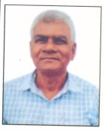
24 | DR. SHEO KUMAR SINGH | PROFESSOR | SURGERY | FT | DMS KOLKATA | 4/1/1966 | 27888 DT 19/1/2007 BIHAR STATE BOARD OF HOM. MED. | DEMONS.- 4/7/97 TO 6/8/2002 LECT. 7/8/2002 TO 15/12/08 READER 16/12/2008 TO 29/9/2011 IN BHMCH, AND AT GDMHMCH AS READER FROM 1/10/2011.TO 31/08/2021 Professor since 01/09/2021 | 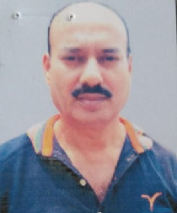
25 | DR. TARIQUE ANWER | ASSOCIATE PROFESSOR | SURGERY | FT | MBBS (THE Tamilnadu Dr. M.G.R. Medical college, 2008  M. S. – (Gen. surgery) The West Bengal College of Health Science. 2012 | 02/08/1982 | 41110 BIHAR COUNCIL OF CENTRAL REGISTRATION DT 17/10/2012 | LECTURER AT GDMHMCH FROM 10/08/2019 TO 30/11/2023 AND ASSOCIATE PROFESSOR SINCE 01/12/2023 | 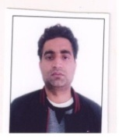
26 | DR. BARUN KUMAR CHATURVEDI BAGISH | ASSOCIATE PROFESSOR | SURGERY | FT | BHMS 2009 MUHS  MD. (HOM.) BRA BIHAR UNIVERSITY -2019 | 20/04/1980 | 5115 DT CCH | LECTURER AT GDMHMCH FROM 01/10/2019 TO 16/03/2025 AND ASSOCIATE PROFESSOR SINCE 17/03/2025 | 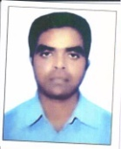
27 | DR. DEEPAK KUMAR DAMAN | ASSISTANT PROFESSOR | SURGERY | FT | BHMS 2009, BRA BIHAR UNIVERSITY  MD. (HOM.) BRA BIHAR UNIVERSITY -2019 | 8/12/1985 | 29248 DATED 2/11/2010 BIHAR STATE BOARD OF HOM. MED | ASSISTANT PROFESSOR AT G D M HOM MED. COLLEGE AND HOSPITAL SINCE 2/12/2024 | 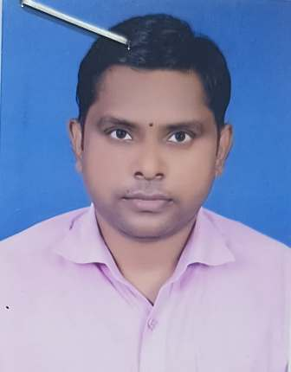
28 | DR. KUMARI SUNITA | PROFESSOR | COMMUNITY MEDICINE | FT | DHMS 1991 BRA BIHAR UNIV | 11/10/1967 | 25104 DT19/4/95  BIHAR STATE BOARD OF HOM. MED. | DEMONS.- 12/7/1995TO 23/8/1999 LECTURER FROM. 24/8/1999 TO 27/7/2002 B.H. H.M.C, BIHAR AND AT GDMHMCH LECTURER FROM 28/7/2002 TO 04/09/2004  READER FROM 5/9/2004 TO 30/09/3019 AND PROFESSOR SINCE 1/10/2019 | 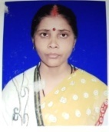
29 | DR. NAND JEE | ASSOCIATE PROFESSOR | COMMUNITY MEDICINE | FT | BHMS 2003 BRA BIHAR UNIVERSITY | 22/7/1971 | 27967 DT27/2/2007 BIHAR STATE BOARD OF HOM. MED. | LECTURER IN PREVENTIVE AND SOCIAL MEDICINE (COMMUNITY MEDICINE ) FROM 28/02/2007 TO 30/09/2011 AT BHMCH, BIHAR AND LECTURER IN GDMHMCH, FROM 01/10/2011TO 30/09/2019 AND READER SINCE 1/10/2019 | 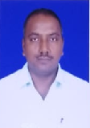
30 | DR. PRABHU NATH PANDIT | ASSOCIATE PROFESSOR  AND STATISTICAL ASSISTANT | COMMUNITY MEDIC INE | FT | BHMS 1994 BRA BIHAR UNIVERSITY | 17/12/1967 | 25886 DT07/11/1998  BIHAR STATE BOARD OF HOM. MED. | DEMONS. IN PSM FROM 20/01/1999 TO15/07/2004, LECTURER FROM 16/07/2004 TO 15/05/2012 AT BHMCH,PATNA AND LECTURER IN GEMHMCH FROM 16/05/2012 TO 31/08/2021 AND READER SINCE 01/09/2021 | 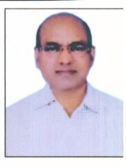
31 | DR. PRAKASH | ASSOCIATE PROFESSOR | COMMUNITY MEDICINE | FT | BHMS 2013 BRA BIHAR UNIVERSITY  M.D. (Hom.) June 2019 BRA BIHAR UNIVERSITY | 22/08/1981 | 31484 dt 19/03/2015  BIHAR STATE OF HOM. MEDI. | LECTURER IN GDMHMCH FROM 01/10/2019 TO 30/11/2023 AND ASSOCIATE PROFESSOR SINCE 01/12/2023 | 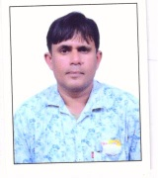
32 | DR. MEGHA LAWER | PROFESSOR | OBSTETRICS AND GYNAECOLOGY | FT | BHMS -2005, UNIV. OF CALCUTTA  M. D. 2012 BRA BIHAR UNIVERSITY | 2/3/1981 | 29492 DT 14/2/2011 BIHAR STATE BOARD OF HOM. MED. | LECTURER FROM 15/01/2013 TO 1/3/2017 READER FROM 2/3/2017 TO 31/12/2024 AND PROFESSOR SINCE 01/01/2025 AT GDMHMCH, PATNA | 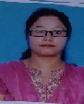
33 | DR. SAJID AKHTAR | ASSOCIATE PROFESSOR | OBSTETRICS AND GYNAECOLOGY | FT | BHMS – 2012 ,DR. BHIMRAO AMBEDKAR UNIV.-AGRA  M.D (HOM) 2019, BRA BIHAR UNIVERSITY | 10/06/1988 | 31610 DT 14/7/2015 BIHAR STATE BOARD OF HOM. MED. | ASSISTANT PROFESSOR FROM 25/10/2019 TO 20/12/2023 AND ASSOCIATE PROFESSOR FROM 21/12/2023 TO 11/08/2024 IN MAGADH HOM. MEDICAL COLLEGE AND HOSPITAL, BIHAR SHARIF  AND ASSOCIATE PROF. AT GD MHMC & H SINCE 14/8/2024 | 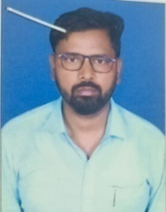
34 | DR. SAIMA YASMEEN | ASSISTANT PROFESSOR | OBSTETRICS AND GYNAECOLOGY | FT | BHMS 2013 BRA BIHAR UNIVERSITY  M.D. (Hom.) 2021 | 03/03/1988 | 31863 dt 09/02/2016 BOARD OF HOM. MEDICINE,BIHAR | AS LECTURER IN GDMHMCH, SINCE 01/03/2021 | 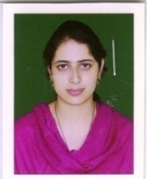
35 | DR. MANJULA PANDEY | ASSISTANT PROFESSOR | OBSTETRICS AND GYNAECOLOGY | FT | BHMS 2012 JIWAJI UNIVERSITY  M.D. (Hom.) FEB. 2021 BRA BIHAR UNIVERSITY | 10/07/1986 | 33559 DT 13/01/2020 BOARD OF HOM. MED., BIHAR | ASSISTANT PROFESSOR AT GDMHMCH SINCE 08/04/2021 | 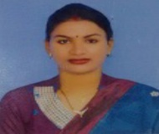
36 | DR. BALWANT KR. SINGH | PROFESSOR | HOM. PHARMACY | FT | BHMS 1996 BRA BIHAR UNIVERSITY | 31/1/1970 | 26218 DT 21/12/1999 BIHAR STATE BOARD OF HOM. MED. | AT GDMHMC DEMONS. 25/1/2001 TO 11/8/2004 LECT 12/8/2004 TO 2/3/2010 READER FROM 3/3/2010 TO 31/08/2023 AND PROFESSOR SINCE 01/09/2023 | 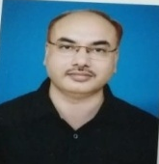
37 | DR. BHAWANI SHANKAR | ASSOCIATE PROFESSOR | HOM. PHARMACY | FT | BHMS 2011, BRA BIHAR UNIVERSITY, M.D (HOM.) 2021 BRA BU | 03/04/1984 | 31579 DATED 26/05/2015 BIHAR STATE BOARD OF HOM. MED. | LECTURER FROM 01/4/2021 TO 31/3/2025 AND ASSOCIATE PROFESSOR SINCE 01/04/2025 IN GDMHMCH | 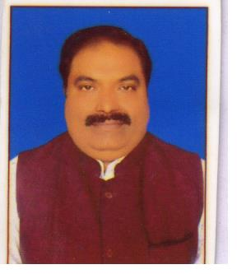
38 | DR. MANISH KUMAR JAISWAL | ASSITANT PROFESSOR | HOM. PHARMACY | FT | BHMS 2013, BRA BIHAR UNIVERSITY, M.D (HOM.) 2021 BRA BU | 08/05/1992 | 31370 DT  20/01/2015 BIHAR STATE BOARD OF HOM. MED. | ASSISTANT PROFESSOR SINCE 08/10/2022 IN GDMHMCH | 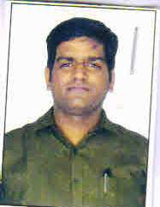
39 | DR. VIKASH KUMAR GUPTA | ASSITANT PROFESSOR | HOM. PHARMACY | FT | BHMS 2018, BRA BIHAR UNIVERSITY, M.D (HOM.) 2023 BRA BU | 22/06/1991 | H-0388839 DATED 29/11/2029  . | ASSISTANT PROFESSOR SINCE 08/08/2024 IN GDMHMCH | 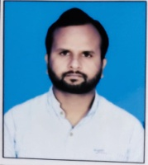
40 | DR. VIKASH KUMAR PANDEY | ASSITANT PROFESSOR | HOM. PHARMACY | FT | BHMS 2013, BRA BIHAR UNIVERSITY, M.D(HOM.) 2021 BRA BIHAR UNIVERSITY | 08/05/1987 | H-034456 DATED-02/04/2015  HOM.MEDICINE BOARD,U.P LUCKNOW0 | ASSISTANT PROFESSOR FROM 01-08-2022 TO 30-08-2025 IN MUZ. HOM.MEDICAL COLLEGE & HOSPITAL AND ASSISTANT PROFESSOR SINCE  01-09-2025 IN GDMHMCH
41 | DR. ANIRUDH PRASAD | PROFESSOR | HOM. MATERIA MEDICA | FT | DHMS 1986 BRA BIHAR UNIVERSITY | 5/6/1963 | 22561 DT 1/5/1987  BIHAR STATE BOARD OF HOM. MED. | DEMONS.- 20/8/87 TO 12/9/2006 LECT. 13/9/2006 TO 16/7/2012 B.H. MCH, PATNA AND READER AT GDMHMCH FROM 17/07/2012 TO 02/01/2022 AND PROFESSOR SINCE  03/01/2022 | 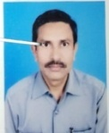
42 | DR. VIJAY KUMAR UPADHYAY | PROFESSOR ON CONTRACT BASIS | HOM. MATERIA MEDICA | FT | DHMS 1979 BRA BIHAR UNIVERSITY | 15/5/1957 | 20011 DT 24/4/1982 BIHAR STATE BOARD OF HOM. MED. | DEMONS.- 12/7/1990 TO 11/8/1995, LECT. 12/8/95 TO 02/3/2000 READER 3/3/2000 TO 7/8/2006 PROFESSOR. -08/8/2006 TO 31/3/2009 B.H. MCH, PATNA AND PROFESSOR AT GDMHMCH FROM 01/04/2009-14-05-2024 and Prof. On Contract Basis SINCE 15-05-2024 | 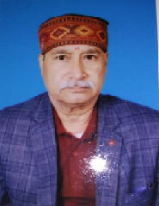
43 | DR. VINOD KUMAR SINGH | ASSOCIATE PROFESSOR | HOM. MATERIA MEDICA | FT | BHMS 1997 BRA BIHAR UNIVERSITY | 01/06/1972 | 26304 DT 8/4/2000 BIHAR STATE BOARD OF HOM. MED. | LECTURER AT GDMHMCH FROM 01/08/2004 TO 02/01/2022 AND ASSOCIATE PROFESSOR SINCE 03/01/2022 | 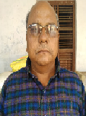
44 | DR. NITISH KUMAR SINGH | ASSOCIATE PROFESSOR | HOM. MATERIA MEDICA | FT | BHMS 2013 BRA BIHAR UNIVERSITY  M.D. (HOM.) 2019 BRA BU | 10/02/1991 | 31374 DT 20/01/2015 BOARD OF HOM MED. | LECTURER AT GDMHMCH FROM 01/10/2019 TO 30/11/2023 AND ASSOCIATE PROFESSOR SINCE 01/12/2023 | 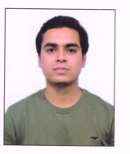
45 | DR. PRASHANT SINGH GAUTAM | ASSISTANT PROFESSOR | HOM. MATERIA MEDICA | FT | BHMS JULY 2015 BRA BIHAR UNIVERSITY  M.D. (HOM.) DEC. 2020 BRA BU | 15/07/1991 | 32327 DT 13/05/2017 BOARD OF HOM MED. BIHAR | ASSISTANT PROFESSOR AT GDMHMCH SINCE 04/08/2023 | 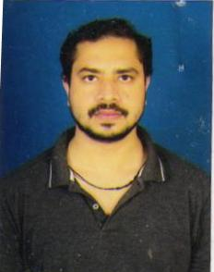
46 | DR. MONIKA SINHA | ASSISTANT PROFESSOR | HOM. MATERIA MEDICA | FT | BHMS 2013 BRA BIHAR UNIVERSITY  M.D. (HOM.) 2021 BRA BIHAR UNIVERSITY | 20/05/1990 | 31593 DT 9/6/2015 BIHAR STATE BOARD OF HOM. MED. | LECTURER AT GDMHMCH SINCE 01/03/2021 | 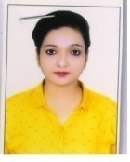
47 | DR. KAMESHWAR PRASAD | PROFESSOR | ORGANON OF MEDICINE | FT | DHMS 1985 BRA BIHAR UNIVERSITY | 25/03/1962 | 22129 DT 29/5/1986 BIHAR BOARD OF HOM. MED. | DEMO.- FROM 8/6/2002 TO 21/09/2005, LECTURER FROM 22/9/2005 TO 4/10/2009, READER FROM 5/10/09 TO 18/10/2016, PROFESSOR FROM 19/10/2016 TO 30/9/2019 AT RKDHMCH, MOTIHARI  IN GDMHMCH PROFESSOR SINCE 01/10/2019 | 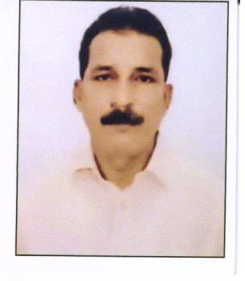
48 | DR. ANIL KUMAR SINGH | PROFESSOR | ORGANON OF MEDICINE | FT | BHMS 1991 BRA BIHAR UNIV. | 1/6/1965 | 32923 DT  31/07/2019 BIHAR BOARD OF HOM. MED. | LECTURER 23/11/2001 TO 31/5/2006, BHMCH, PATNA, IN GDMHMCH AS READER FROM 01/6/2006 TO 31/08/2023 AND PROFESSOR SINCE 01/09/2023 | 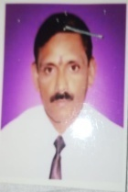
49 | DR. DANISH AEJAZ | ASSOCIATE PROFESSOR  TEACHER IN FUNDAMENTAL OF PSYCHOLOGY | ORGANON OF MEDICINE | FT | BHMS 2009 BRA BIHAR UNIVERSITY  M.D. (HOM.) 2019 BRA BIHAR UNIVERSITY | 3/12/1982 | 29249 DT 02/11/2010  BIHAR STATE BOARD OF HOM. MED | LECTURER AT GDMHMCH FROM 01/10/2019 TO 30/11/2023 AND ASSOCIATE PROFESSOR SINCE 01/12/2023 | 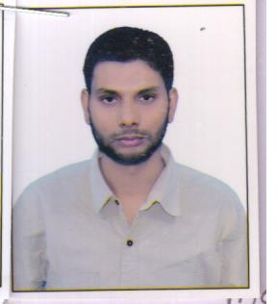
50 | DR. AWALESHWAR KUMAR | ASSISTANT PROFESSOR | ORGANON OF MEDICINE | FT | DHMS 1991 BRA BIHAR UNIVERSITY | 2/7/1965 | 25138 DT 12/7/1995 BIHAR STATE BOARD OF HOM. MED. | DEMONS.- 06/12/95 TO 12/9/2003 LECT. 13/9/2003 TO 16/9/2011 IN Organon of Medicine B.H. MCH, PATNA, IN GDMHMCH AS LECTURER IN ORGANONON OF MED. SINCE 17/09/2011 | 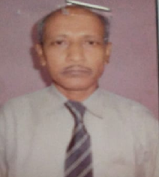
51 | DR. SUKIRTI KUMARI | ASSISTANT PROFESSOR | ORGANON OF MEDICINE | FT | BHMS 2013 BRA BIHAR UNIVERSITY  M.D. (Hom.) FEB. 2021 BRA BIHAR UNIVERSITY | 05/02/1992 | 31466 DT 10/3/2015 BOARD OF HOM. MED., BIHAR | AS LECTURER IN GDMHMCH SINCE 01/09/2023 | 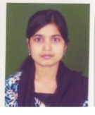
52 | DR. ASHOK KUMAR GUPTA | PROFESSOR | REPERTORY | FT | BHMS 1993 BRA BIHAR UNIV. | 01/07/1968 | 25751 DT 1/4/1998 BIHAR STATE BOARD OF HOM. MED. | DEMONS. 2/2/2001 TO11/8/2004  LECT. -12/8/2004 TO14/9/2012  READER FROM 15/9/2012 TO 31/08/2021 AND PROFESSOR SINCE 01/09/2021 .AT GDMHMCH, PATNA | 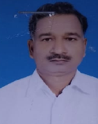
53 | DR. ASHOK KUMAR PANDEY | ASSOCIATE PROFESSOR | REPERTORY | FT | BHMS 1983 BRA BIHAR UNIVER  SITY | 1/2/1961 | 26135 DT 1/10/1999 BIHAR STATE BOARD OF HOM. MED. | APPOINTED PROVISIONALLY AS DEMONSTRATOR IN REPERTORY FROM 30/01/1996 TO20/9/2011 AT BHMCH AND  LECTURER FROM 1/10/2011 TO 31/08/2021.AND READER SINCE 01/09/2021 IN GDMHMC, PATNA | 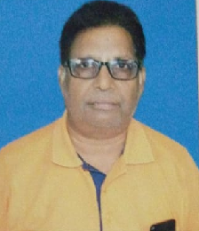
54 | DR. RITU JAISWAL | ASSISTANT PROFESSOR | REPERTORY | FT | BHMS 2014 BRA BIHAR UNIVERSITY  M.D. (HOM.) 2021 BRA BIHAR UNIVERSITY | 28/10/1988 | H035635 DT. 02/08/2016 HOMOEOPATHIC MEDICINE BOARD, U.P  CCH REG. NO- 200069 | LECTURER IN GDM HOM. MED. COLLEGE SINCE 01/03/2021 | 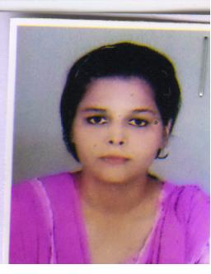
55 | DR. PRINCE KUMAR AZAD | ASSISTANT PROFESSOR | REPERTORY | FT | BHMS 2018  UNIVERSITY OF DELHI  MD (HOM) 2021  DR. BR AMBEDKAR UNIVERSITY, AGRA | 5/3/1991 | H039874 DT. 24/08/2021  NRH/0002163 | LECTURER IN GDM HOM. MED. COLLEGE SINCE 08/08/2024 | 